Saint John Neumann _
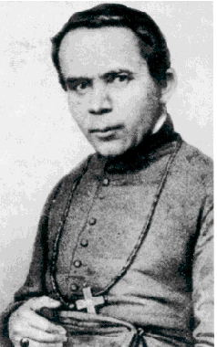
Born: March 28th, 1811
Died: January 5th, 1860
Canonized: Jun 19th ,1977
Feast: January 5th
Patronage: Catholic Educators, Sick children, Immigrants, The United States
Fun Fact: First U.S Saint, first relic under my care during the 250th celebration of U.S founding.

<Image of Relic>
History of Relic:
Recipient | Date received | Date Returned | Intention
Joseph Samo |  | 5/29/2026 | America
Probst Family
Wisehaupt Family

